
Reka Bentuk Antara Muka Berasaskan Web
(CSF3133)

LAB REPORT 3

NAME: CHIA FU YAN
MATRIC: S75039
DATE: 5/11/2024
GROUP: K4
PROGRAM: Computer Science (Software Engineering)
LECTURER: Miss Wan Fatin

3.2 Block and Inline Elements
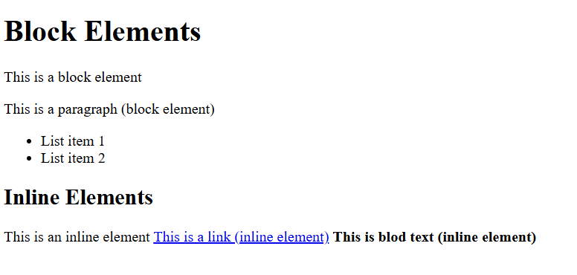

3.3 using <div> to Organize Content
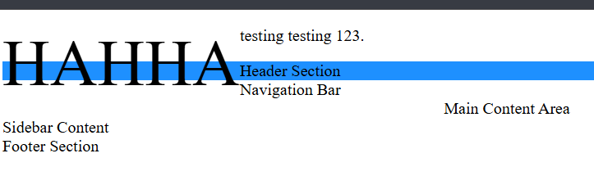

3.4 Understanding HTML Entities
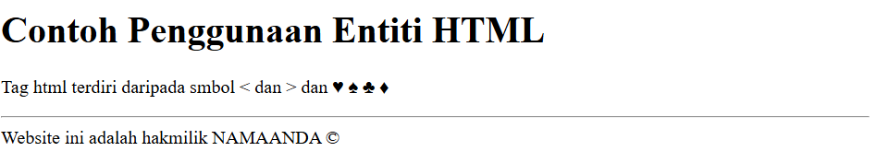

3.5 Hypertext Mark Up Language 5 (HTML5)
Step 3
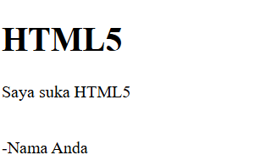
Step 5
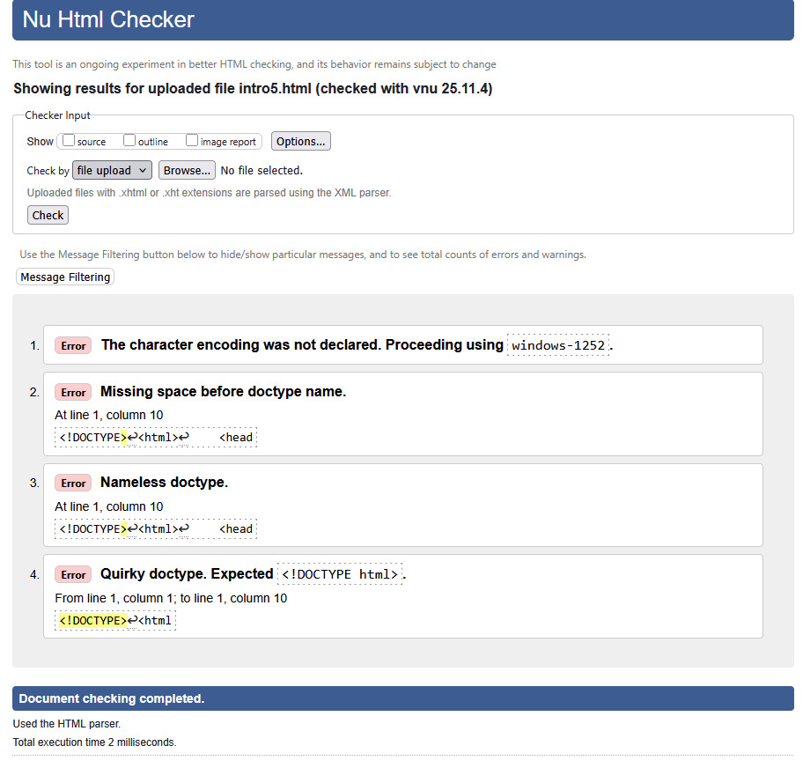
Step 7
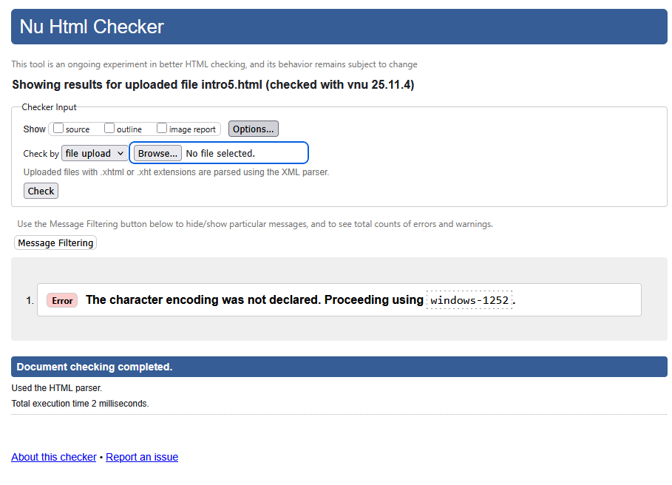
In conclusion, from step 5 I found that 3 errors appeared, and my HTML5 file does not comply with the requirement because the doctype in my file is nameless.

3.6 Form Elements in HTML5
3.6.1 Input Elements in HTML5

Step 3
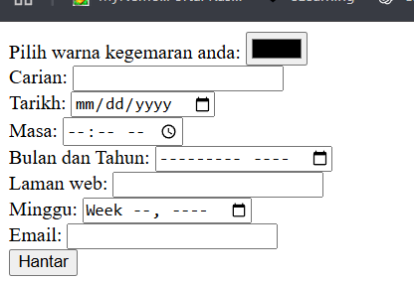

Step 4
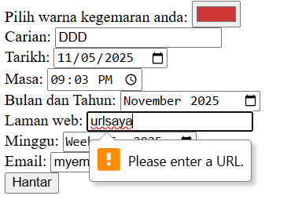

3.6.2 Attributes for Input HTML5

Step 3
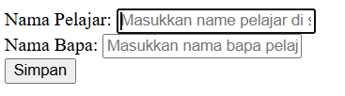

Step 4
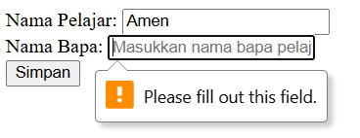
The warning occurs because the field is empty.

Step 5
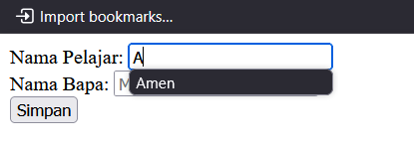
The history content has occurred with a drop-down list. The autocomplete function works.

3.6.3 HTML5 <output> element
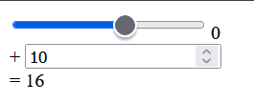

3.7 Lab Exercise 3
Source Code
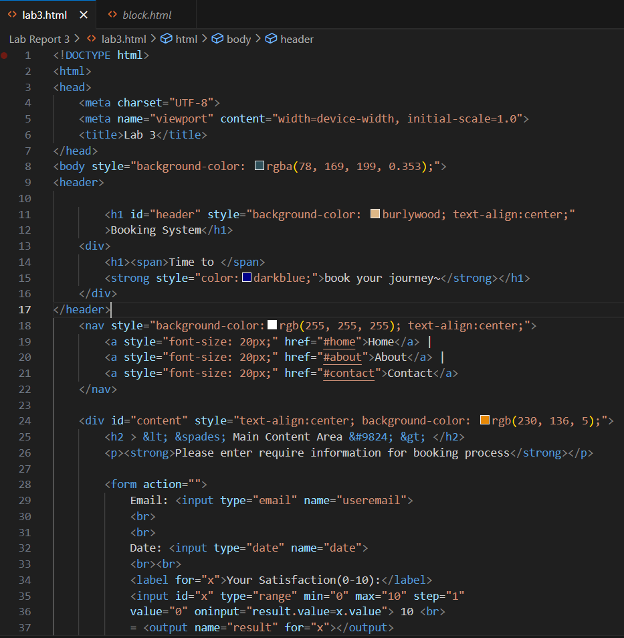
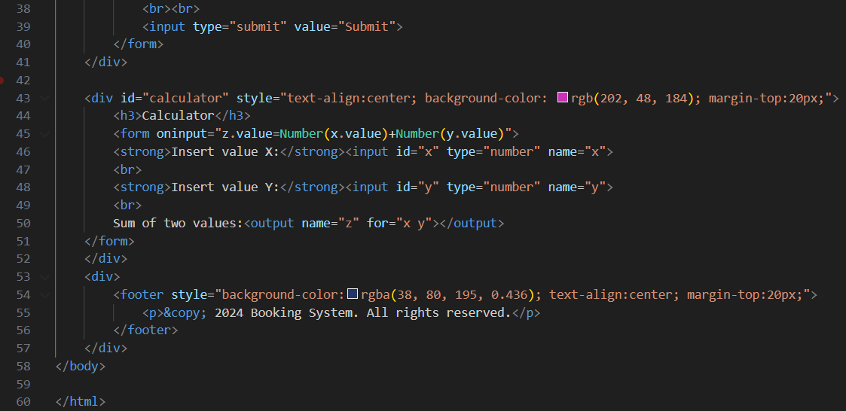
Output
